Children and Sexual Offences:

An analysis of some custody, arrest and reporting trends



On behalf of the Children’s Project

Community Law Centre
University of the Western Cape

5 June 2002

by Jean Redpath
43 Milton Road, Observatory, 7925
(021) 448 1086; fax (021) 448 1086; 083 231 6349 (cell)
redpath@iafrica.com

Table of contents
Table of contents 2
Acknowledgements 3
Executive Summary 4
Child sex offenders in custody in South Africa 5
All Sex Offenders 5
Child Sex Offenders 7
Arrests of children for sexual offences in the Western Cape 12
Rape and indecent assault arrest trends 13
Other sexual offence arrest trends 14
Outcome of arrests of children 14
In the context of national rape reporting trends 18
Sexual offences perpetrated against children 19
Arrests by the East Metro Child Protection Unit 19
Analysis by age of alleged perpetrators 20
Analysis of child and adult alleged perpetrators: variation with time 22
Analysis by type of offence: indecent assault and rape 24
Comparison with social fabric crime in the Northern Cape 27
Childline Research Statistics 29
Selected findings of other research 31
Conclusions 32

Acknowledgements
The following people in particular are to be thanked for their assistance in providing the data, without which this project would not have been possible: Ms Lizzie Masango of the Correctional Services National Office; Inspector Jansen of SAPS Provinical Commissioner’s Office in the Western Cape; Superintendent Swart of the SAPS East Metro CPU; Lynne Cawood of Childline Gauteng; and Calle Hedberg of HSIP who provided the predictive tables of national and provincial populations by age-group.

Executive Summary

- The number of children sentenced for sexual offences in South African prisons is decreasing.
- The number of children in custody for sexual offences, but not sentenced, is increasing.
- Since January 1999, more children in custody for sexual offences are un-sentenced than sentenced, which is the reverse of the normal pattern of more sentenced than un-sentenced prisoners.
- The number of children in prison at any time 1998-2001 did not exceed 700: less than 4% of sex offenders in prison are children.
- The number of all sex offenders in prison is increasing at a rate of 138 a month.
- The number of children arrested in the Western Cape for sexual offences has not yet exceed 500 in one year, and is increasing at a rate of 38 arrests a year.
- This number constitutes 6% of all reports of rape, attempted rape, and indecent assault in the Western Cape.
- Just under a half of all children arrested for sexual offences in the Western Cape are prosecuted; about 5% are diverted, while it is not known what the outcome is in 25% of cases.
- Children were arrested in 23% of recent East Metro CPU cases for crimes against other children, with large monthly fluctuations.
- The number recorded by the CPU of such crimes committed by children is increasing, but at a lower rate than for adults.
- Children were arrested for a larger proportion of cases of indecent assault than their average for all crimes recorded.
- Children were arrested for a smaller proportion of cases of rape than their average for all crimes recorded.
- The 18-30 age-group is responsible for most rapes and contributes more to such crimes than predicted by their share of the population.
- A study on social fabric crime in the Northern Cape is consistent with these East Metro findings.
- Research by Childline shows that the 15-20 age-group accounts for 35% of all calls regarding child sex abuse recorded by Childline.
- Childline also shows that the under 15 age-group accounts for 19% of all calls regarding child sex abuse.
- The under 15, 15-20 and 30-40 population groups accounted for more Childline perpetrators than predicted by their population share.

Child sex offenders in custody in South Africa

The Department of Correctional Services has provided figures on sex offenders in custody in South Africa. The figures provided show the average number of sentenced and un-sentenced prisoners (adults and children, men and women) in custody in each month in respect of sexual offences for the period January 1998 to December 2001. The Department has also provided the same information for children in custody (boys only). They have also provided subtotals for children of different ages. The term ‘sentenced’ appears to include those awaiting trial and those convicted but not yet sentenced.

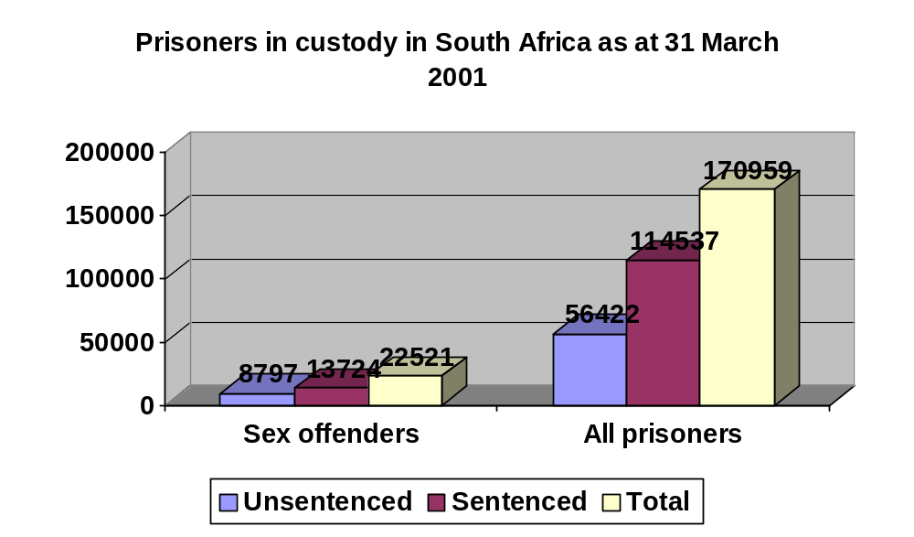All Sex Offenders

The table on the left shows total numbers of sentenced, un-sentenced and all sex offenders in prison at March 2001. It also shows the number of all prisoners in custody in those categories.

Sex offenders comprise 13% of all prisoners, 12% of sentenced prisoners, but 16% of un-sentenced prisoners. This might be a reflection of the difficulty in obtaining convictions for sexual offences.

The graph on page 14 plots the number of sex offenders in prison on a month-by-month basis, beginning in January 1998.

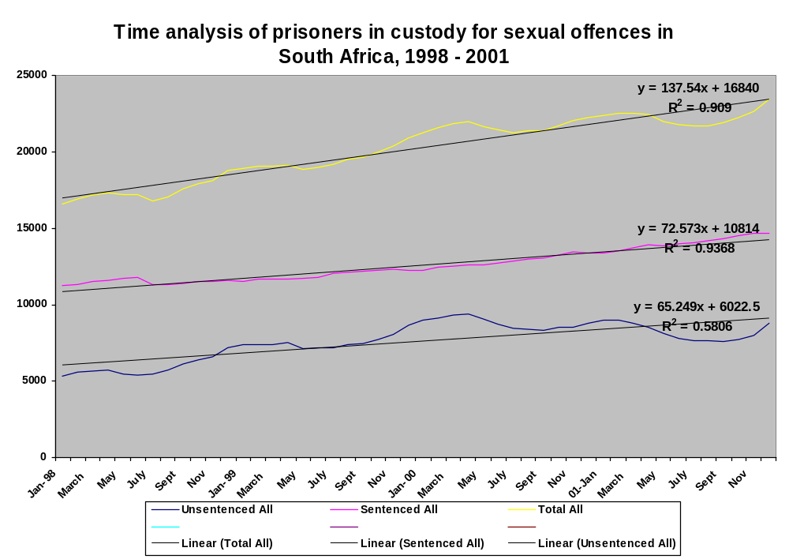
A linear equation plotted to the total numbers shows that the total number of sex offenders in prison is increasing at a rate of 138 prisoners a month (m=137.54). The numbers fit a straight line almost perfectly (R²= 0.909) which means we can use the equation to predict the number of prisoners in future months. The number of prisoners sentenced for sexual offences is increasing at a rate of 72 prisoners per month (m=72.573), and the fit to a straight line is even better (R²=0.9368) than for total prisoners, showing a very steady predictable increase.

There are fewer un-sentenced sex offenders in prison at any particular time than there are sentenced, and the difference is growing. Un-sentenced prisoners are increasing at a rate 65 of prisoners a month. However, the number of un-sentenced prisoners fluctuates more widely with time, as compared to sentenced prisoners (R²=0.5806). Local peaks seem to occur in the period November to March of each year. This coincides with the court recess and the summer months in South Africa.

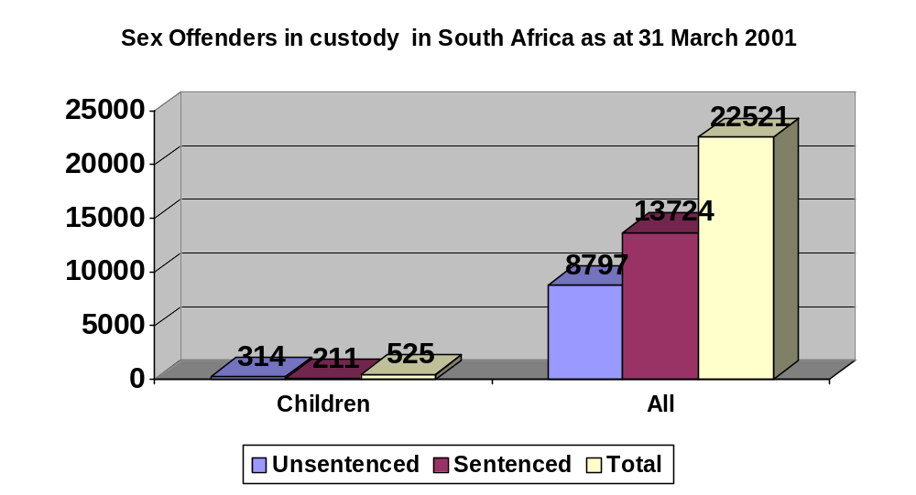Child Sex Offenders

The table on the left shows the number of sex offenders in custody in March 2001, comparing values for children and the total number. It is immediately clear that children make up a very small proportion of sex offenders in custody: only 2.3% of the total, 1.6% of sentenced prisoners, and 3.6% of un-sentenced prisoners.

How does this compare with child offenders of all crimes? There were 6062 child offenders in prison in March 2001, which is 3.5% of all prisoners (170959); in other words, child sex offenders comprise a somewhat smaller proportion of sex offenders, compared to the proportion of child offenders in custody for all offences. The graphs below will look at child sex offenders in custody in more detail.

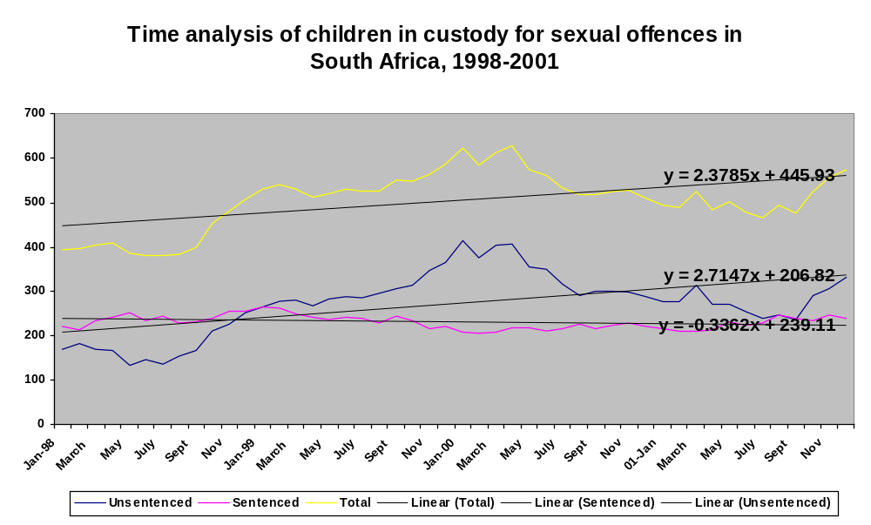

The graph on the previous page plots the total number of children in custody for sexual offences on a month-by-month basis from January 1998 to December 2001. The first thing to note is that in January 1999, the number of un-sentenced child sex offenders overtook sentenced child sex offenders, climbing to a peak in January 2000, and remained higher than sentenced offenders, apart from a brief dip at the end of 2001. This is the reverse of the situation for prisoners generally (usually more are sentenced than un-sentenced), and may relate to policy changes and controversy around child prisoners over that period.

The total number of child sex offenders in prison is increasing at an approximate rate of 2 per month (m=2.3785), but the straight line is a poor fit (R²<3) so the equations for all three lines are not predictive, but can show an increasing or decreasing trend. Un-sentenced child sex offenders are increasing a rate of almost 3 per month (m=2.873). By contrast, sentenced child sex offenders are decreasing at a rate of about 1 every three months (m=-0.3362).

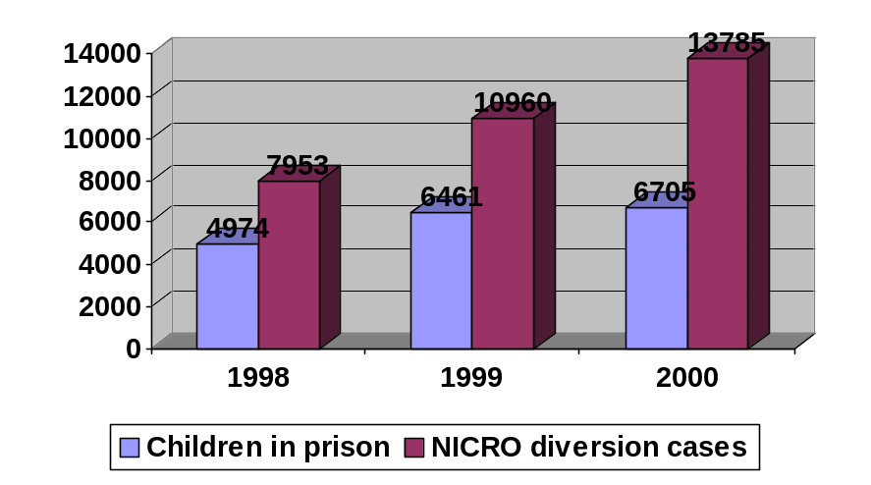The two graphs on the following pages further break down the un-sentenced and sentenced child sex offenders by age. Both of these graphs show the overwhelming contribution of children aged sixteen and seventeen. It is interesting to note that for sentenced child sex offenders, the seventeen year olds make by far the greater contribution, in the region of 60%, while the un-sentenced graph shows sixteen and seventeen year old to be closer in contribution (indeed sixteen year olds overtake seventeen year olds briefly in September 1999).

It is clear from the data in the sections that follow that children are perpetrating more than 3% of sexual crimes, yet only about 3% of persons in prison for sexual offences are children. What is happening to these children? The table at left shows that NICRO diverts more children each year than are in prison at a chosen point in a year. However, about 73% of NICRO’s diversion cases are for property-related crimes. The table also does not strictly compare the same things: NICRO records the total number of children it dealt with in a year; the prison numbers reflect the number in prison at a particular time. Correctional services does record the total number passing through its doors in a year, but rather, the average number in prison in each month. The section on arrests following will explore the outcomes of arrests of children for sexual offences in more detail.

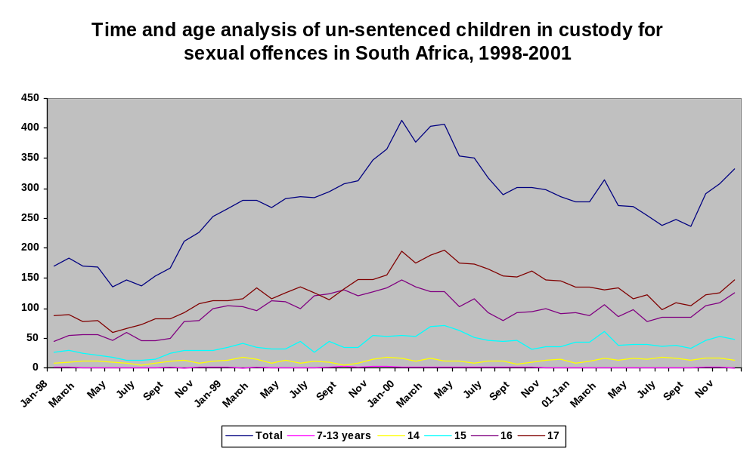

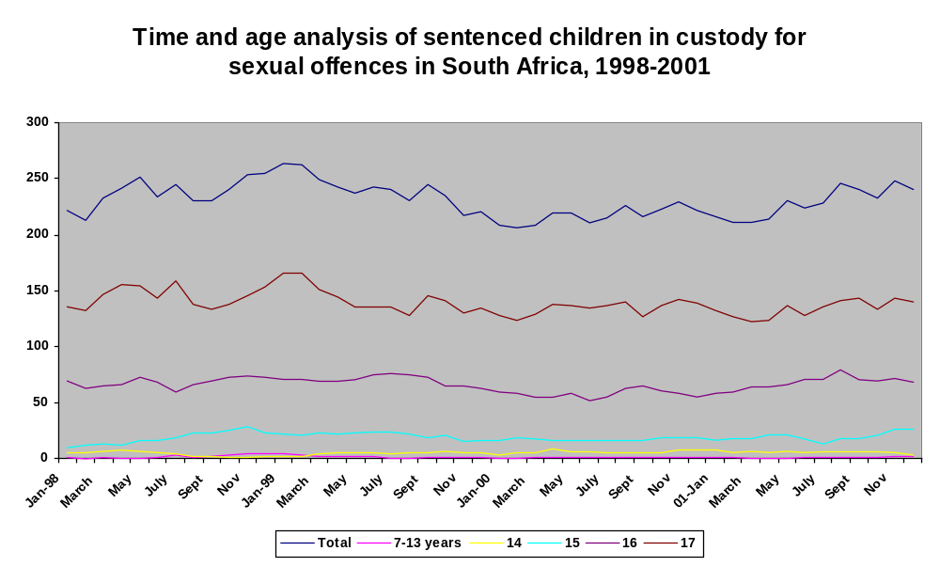

Arrests of children for sexual offences in the Western Cape

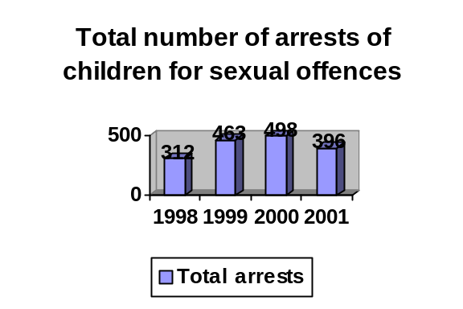The office of the Provincial Commissioner of the SAPS in the Western Cape has provided figures for the total number of persons 17 years and younger arrested for sexual offences during the period 1 January 1998 to 31 December 2001. The figures are reflected in the graphs on this and the following page.

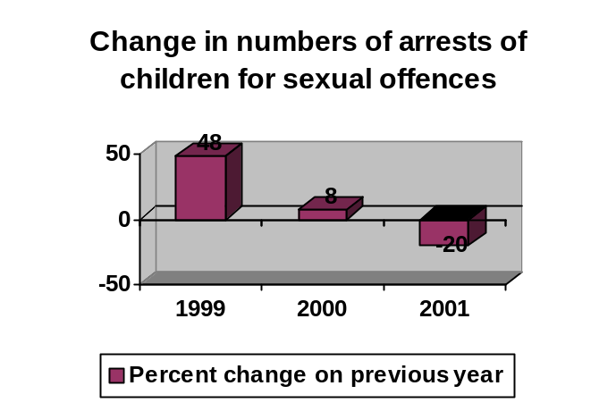Over this four-year period, more children (498) were arrested in 2000 than in any other year; however, the greatest percentage increase on a previous year was recorded in 1999. The lowest number of arrests (312) was recorded in 1998. The percentage change in numbers of arrests is reflected in the graph on the right. This appears to show a decrease in the rate of increase: indeed from 2000 to 2001 we find a decrease of 29% on the previous year.

A linear equation fitted to the total arrests shows that the trend is toward an increase in the number of children arrested each year, at the rate of just under 30 arrests per year (m=28.7). The fit to a straight-line graph is poor, however, (R² < 0.3), so this rate of increase must be seen only as showing a trend, and the equations cannot be used to predict values in a particular year.

It also indicates that changes in factors affecting arrest, not correlated with changes over time, are responsible for the fluctuation in the number of arrests. (Population, for example, changes over time and would be a factor affecting the number of arrests closely correlated with time).

It is also worth noting – as we shall see in the statistics for the Western Cape and South Africa as a whole at the end of this section – that the arrest of 470 children in the Western Cape represents 6% of the total (8971) reports of rape, attempted rape and indecent assault in the Western Cape, and 0.1% of all such reports (56993) in South Africa as a whole.

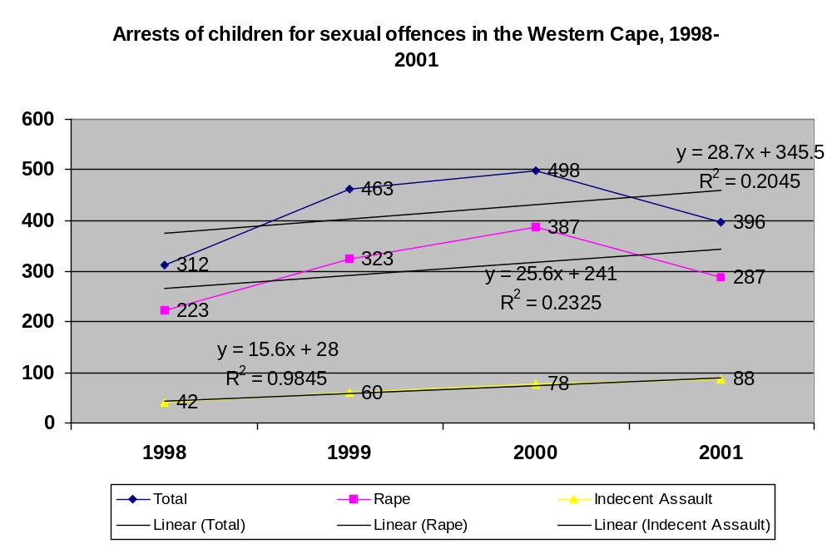Rape and indecent assault arrest trends
It is also interesting to note that the total increase in Western Cape arrests of child sex offenders is almost entirely due to an increase in the number of child arrests for rape, which are increasing at a rate of just over 25 a year (m=25.6), although the fit to a straight line graph is again poor. The peak in total figures in 2000 is also due to a peak in rape figures.

The rate of increase in child arrests for indecent assault, however, at just under 16 per year, matches a straight line very well (R² = 0.98), which indicates that the increase is closely correlated with factors that change with time, and the graph can be used to predict future values in a particular year.

It is unclear why there is this difference in trend with respect to rape (larger overall increase, greater fluctuation due to factors not related to change in time) and indecent assault (smooth small increase, closely correlated with factors changing over time). It may be an indication that child cases of indecent assault are dealt with in a more consistent manner than cases of rape; why this might be, however, is also unclear.

Other sexual offence arrest trends
Rape and cases of indecent assault were not the only kinds of arrests of children for sexual offences that were recorded by the SAPS in the Western Cape. The other arrests supplied in the figures, which account for a small proportion of the total, are reflected in the following graph. The most notable aspect of these figures is the very small numbers involved (except for the category ‘unrecorded’, particularly in 1999, which may be an indication of an error in recording of these arrests). It is of concern that the SAPS still count “sodomy” as a distinct type of crime, despite the 1998 judgment of the Constitutional Court.
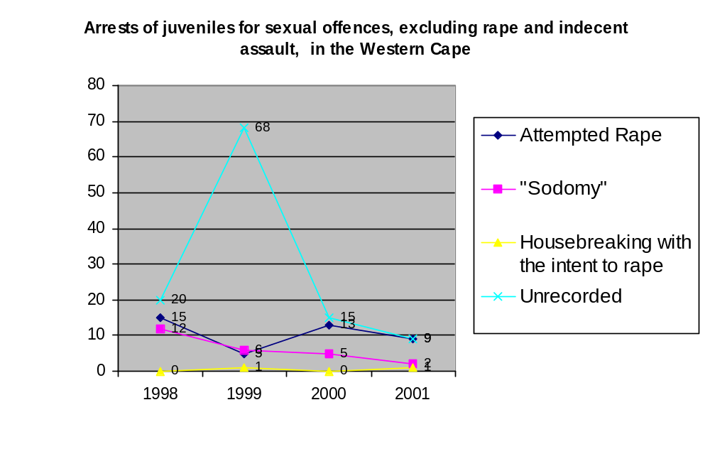The “housebreaking with the intent to rape” category is also of concern, as according to the Criminal Procedure Act 51 of 1977, breaking or entering any premises “with the intent to commit an offence” is a Schedule 1 and a Schedule 2 part 3 offence, in terms of which stricter conditions, such as those in respect of granting bail, apply. However, only 2 such arrests were made over the four years considered.

Outcome of arrests of children
The graphs on the following pages show the various outcomes of those arrests of children for sexual offences in the Western Cape over the four years considered. The figures provided unfortunately do not show the outcome by type of crime. They show only the outcomes with respect to arrests of children for all sexual offences.
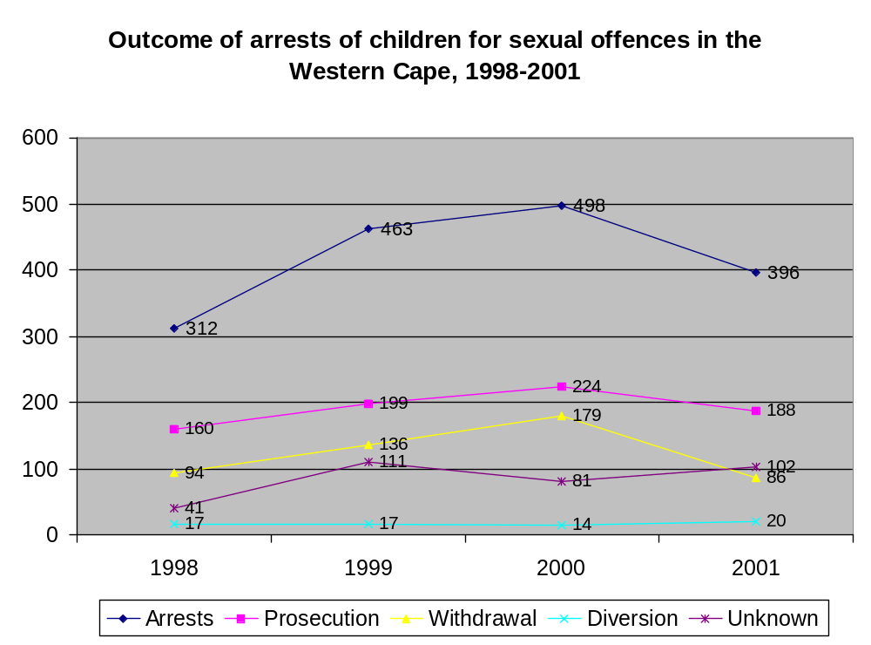

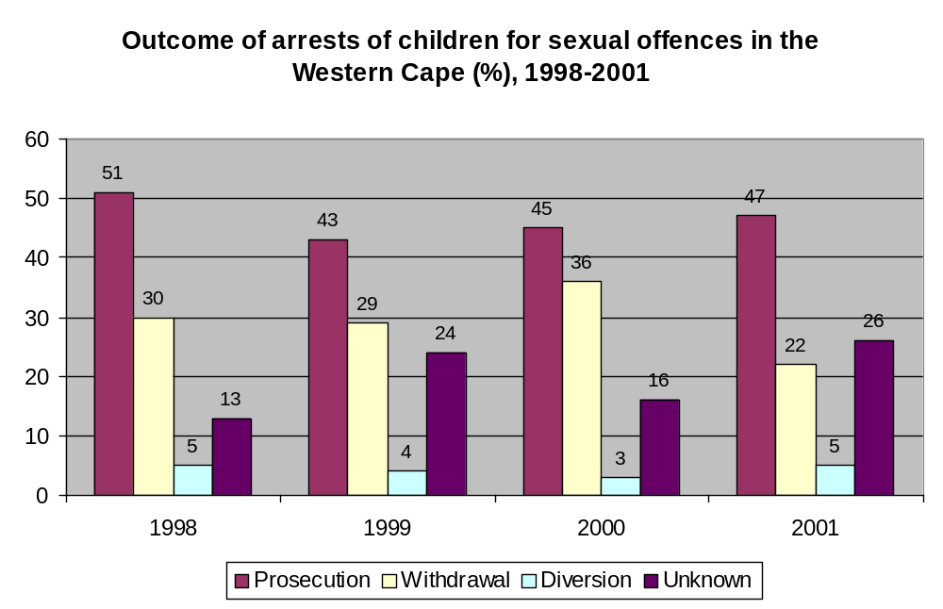The most notable aspect of this data is the that in the region of half of all arrests of children on sexual offence charges leads to prosecution of the offender, while 30% of such cases are simply withdrawn. Only 5% or fewer are diverted from the criminal justice system, which implies that in the region of 40% children faced with enough evidence against them to warrant an arrest, are simply not being dealt with by the criminal justice system at all. What is of concern is that around a quarter of all arrests are simply not accounted for in terms of outcome (‘unknown’).

How does this compare to the situation for all sexual offences in the Western Cape?

Unfortunately the statistics on the following pages regarding the Western Cape and South Africa in 2000 are in respect of numbers of reports, as opposed to numbers of arrests. However, statistics on combined numbers of reports of rapes, attempted rapes, and indecent assaults do provide a useful comparison if not exact comparison. The same general pattern in discerned, with about half the offences being prosecuted, and 30% withdrawn.

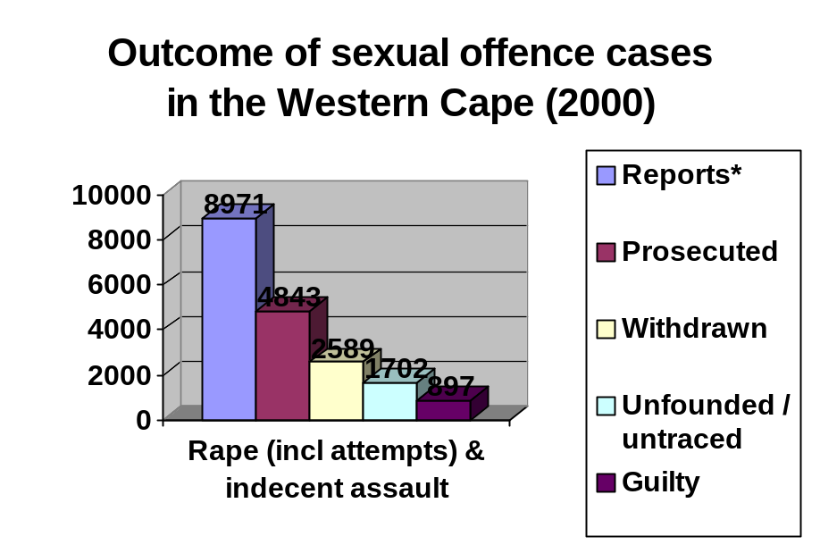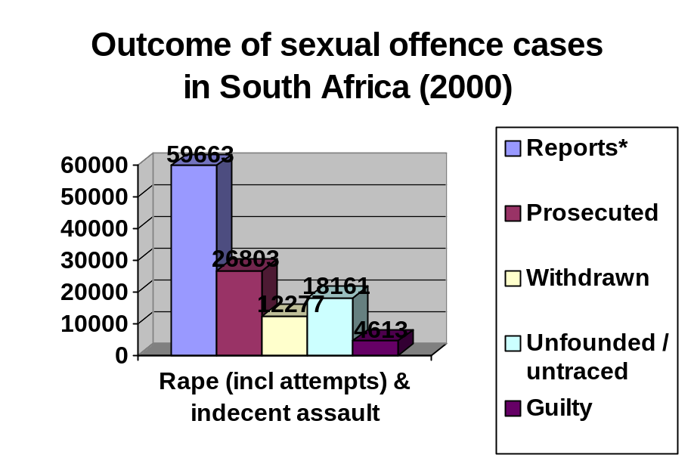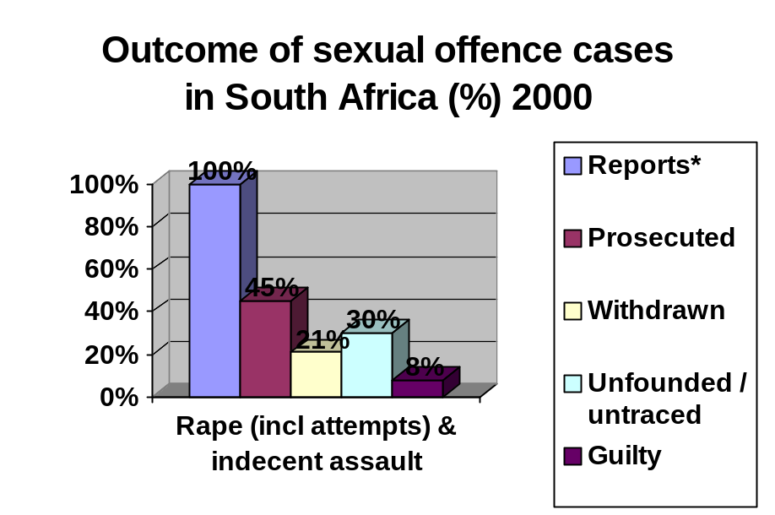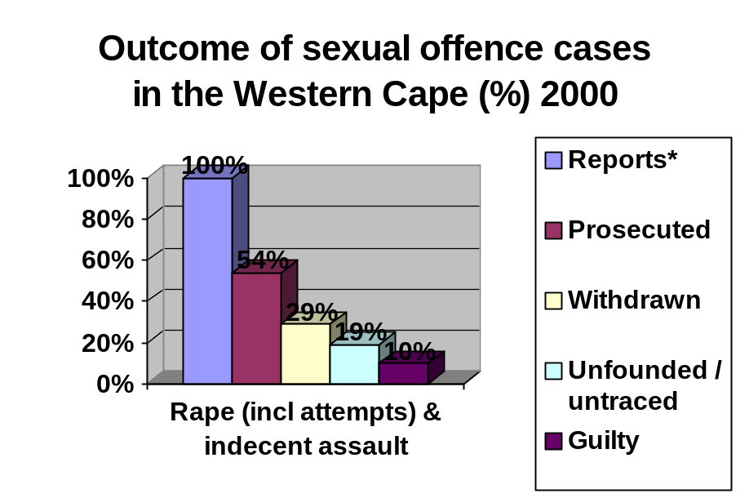 It is interesting to note that the Western Cape records proportionately more such crimes withdrawn, as opposed to being ‘unfounded’ or ‘untraced’, as the average for the country as a whole, and the Western Cape has a somewhat higher proportion of ‘guilty verdicts’.

In the context of national rape reporting trends
It may also be useful at this stage to place the Western Cape data in the national context. The maps on the following pages show the incidence of reported rape in South Africa in 2000. Gauteng, the Eastern Cape and KwaZulu-Natal have the highest numbers of rapes. However, per 100 000, the Northern Cape has the highest incidence, followed by the Western Cape and Gauteng. In other words, the Western Cape data considered in this project is representative of a province which experiences somewhat of a greater problem with sexual crimes than the national average.

Nevertheless, if we assume that the 6% of arrests of children in the Western Cape is roughly the same as the proportion of children arrested across the country, then we should have a child sex offender justice system in place designed, at the very least, to cater for 3180 children per year across the country. The number of children arrested will obviously rise when a mechanism for dealing with them is in place.
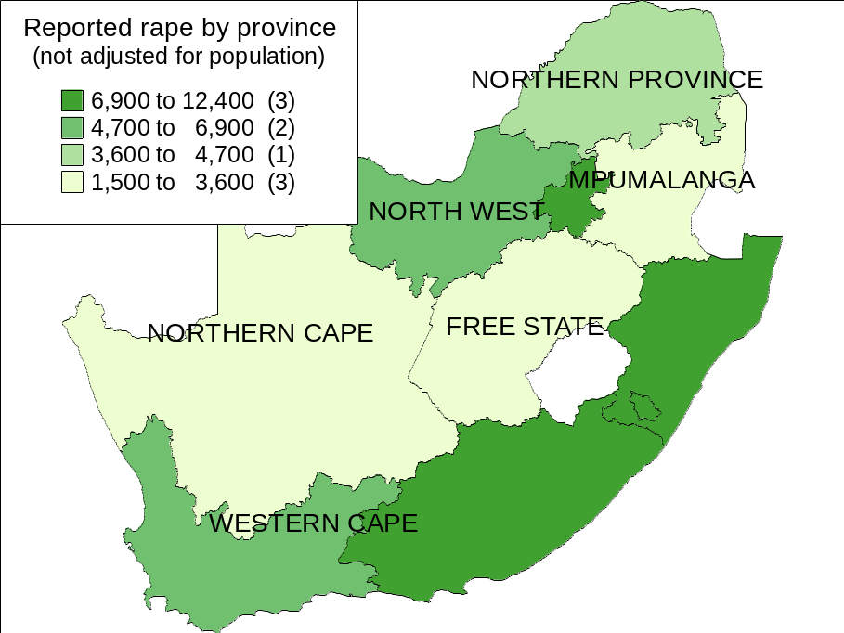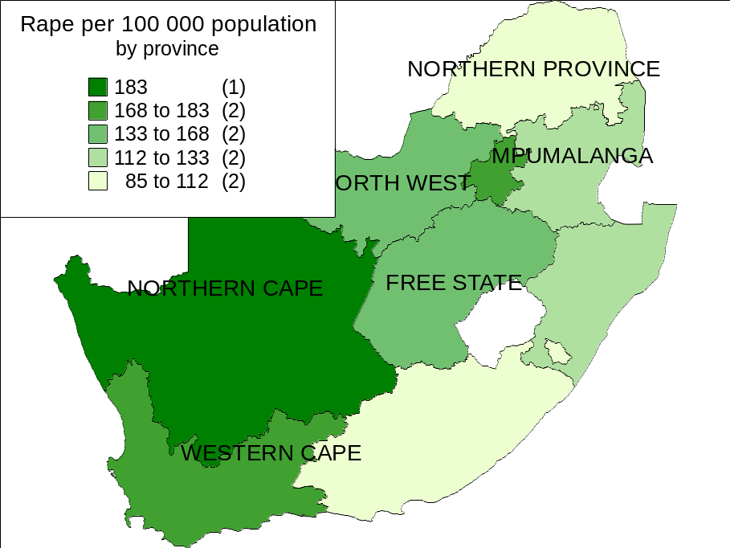

Sexual offences perpetrated against children

Arrests by the East Metro Child Protection Unit
There are 45 Child Protection or Family Violence, Child Protection and Sexual Offences Units (CPU’s and FCS’s) in South Africa. There are two in the Western Cape, one located in Mitchell’s Plain, which serves the West Metropole of the Western Cape, and the other at Goodwood, which serves the East Metropole. The Goodwood CPU has, since April 2000, kept a handwritten record of the ages of all alleged perpetrators arrested in cases referred to the CPU where the victim is under the age of eighteen – a child.

An analysis of this data, which covers the period from April 2000 to end January 2002, by age of the person charged with the crime, provides an indication of the extent to which adults or children are responsible for sexual crimes against other children in metropolitan Western Cape.

Analysis by age of alleged perpetrators
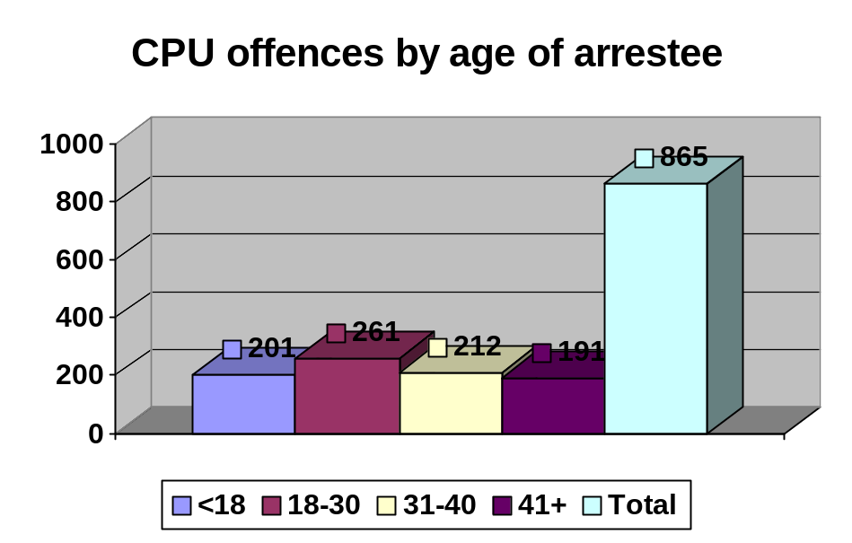
A total of 865 charges were broken down by age, date, and type of offence. The record covered 22 months, which implies an average of 44 cases per month .The ages of persons arrested, ranged from 3 to 83 years of age. The 18-30 age-group was the largest group by age, accounting for 37% (261) charges, followed by the 31-40 age group with 24%, and children with 23% (201).

Children (persons 17 or younger) were charged in 201 cases (23%), implying an average of 9 cases per month. However, averages obscure the large variation recorded from month to month. The graph on page 5 shows, inter alia, the number of offences in each month.

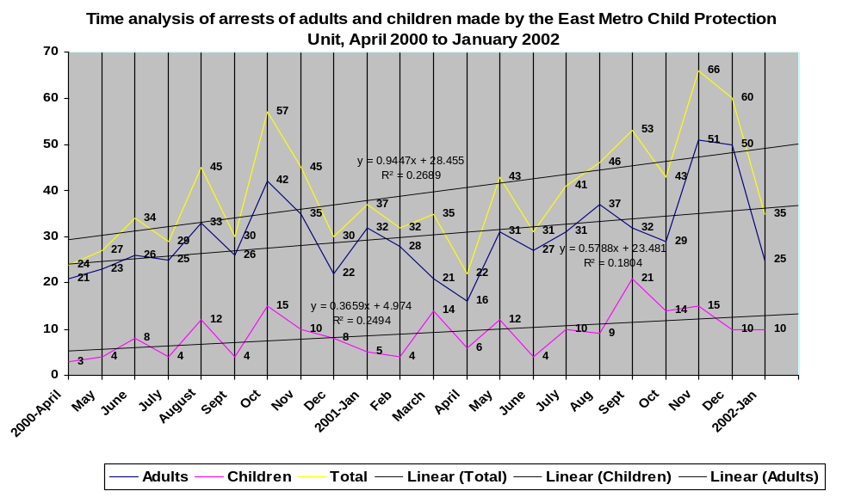

Analysis of child and adult alleged perpetrators: variation with time
The variation is from a minimum of 22 cases in April 2001 to three times as many, that is, 66 cases in November 2001. With respect to child perpetrators, the minimum is 3 cases (April 2000) and the maximum is 21, seven times as many (September 2001). However, various other local peaks and troughs occur before and after these high and low points.

However, despite this variation a trend can be discerned. Linear equations fitted to the data show that the trend is toward an increase in total perpetrators of almost one extra perpetrator per month (m=09447). The trend with respect to children is toward an increase of on average one perpetrator every three months (m=0.3659), while the trend for adult perpetrators is approximately one every second month (m=0.5788). The fit to a straight line graph is poor for all three (R² < 0.3), so these rates of increase must be seen only as showing trends, and the equations cannot be used to predict values in a particular future month.

Note that there does also appear to be a suggestion of a seasonal pattern, with higher values in the latter part of the year (August to December). However, as we only have just under two year’s worth of data available, there is not enough to see whether this trend is valid. What is clear is that a number of other factors must contribute to the highly fluctuating number of arrests per month – which may also relate to factors other than causal factors, such as the number of officers on duty.

What proportions of crimes per month dealt with by the East Metro CPU do children commit? The graph on page 7 shows the percentage of crimes recorded against children allegedly committed by children, for each month. This graph again shows large amount of fluctuation, with a maximum value of 40% allegedly committed by children in March and September 2001, while a minimum of 13% is recorded in April and September 2000, and February 2001. As noted above, on average children were arrested in 23% of crimes.

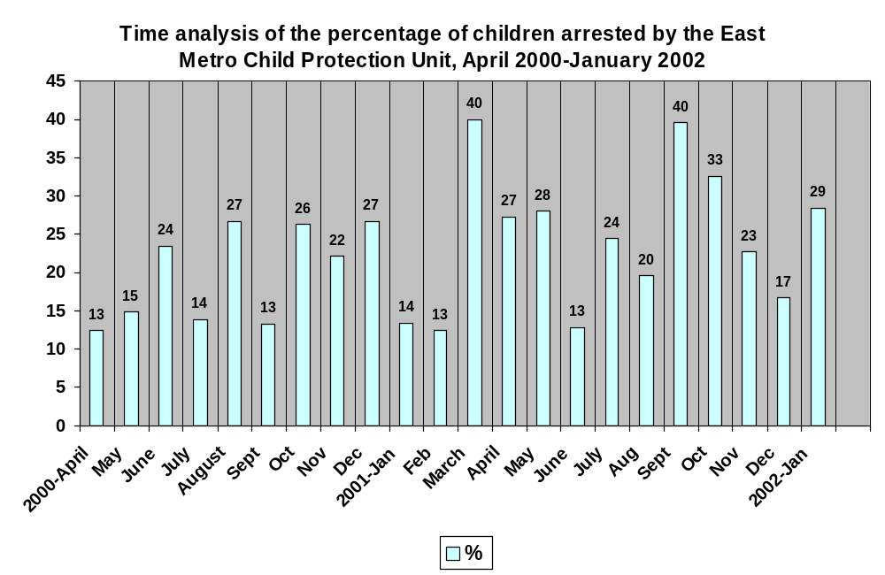

Analysis by type of offence: indecent assault and rape
The majority of the 865 crimes considered here were indecent assault and rape: 49% (428) of perpetrators were charged with indecent assault, while rape (excluding attempts, but including statutory rapes and ‘sodomy’) accounted for 43% (373) of all charges. Other crimes included were attempted murder, assault with intent to cause grievous bodily harm, assault, kidnapping, abduction, and cruelty towards children.

What proportion of all rapes and indecent assault (where the victims were both adults and children) in the East Metro does this sample represent? Of the 801 cases considered in this section, 468 cases occurred in 2000. 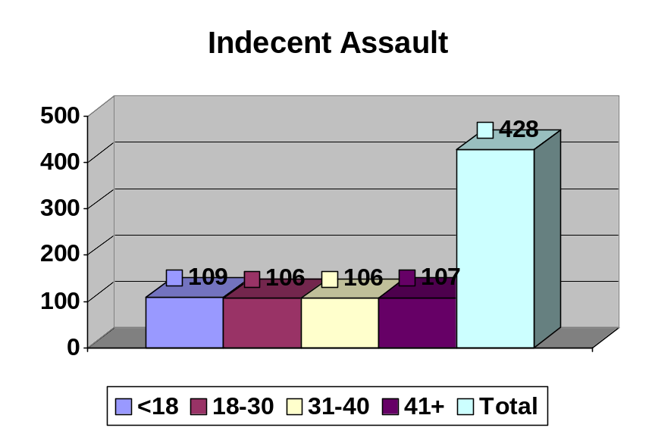According to SAPS statistics, there were 2156 rapes and 728 indecent assaults in the East Metro region during 2000. In other words, 16% of the total cases (adult and child victims) reported in the region during 2000 year, were referred to the East Metro CPU. Therefore, this sample represents in the region of 16% of all such crimes reported.

Of all the indecent assault cases, in 25% (109) a child was charged, which is a slightly higher proportion than the average percentage for children for all crimes. In other words, a slightly higher proportion of children are charged for indecent assault than are charged for all the crimes in the sample. The age groups 18-30, 31-40 and 41+ each accounted for 25% of indecent assault cases.

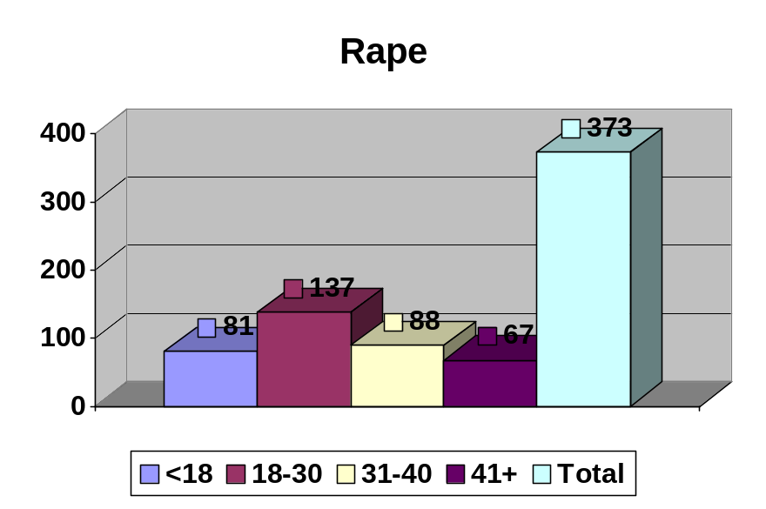

Of the rape cases, 22% (81) were committed by children. This is a slightly lower proportion than the average proportion for children. In other words, a slightly lower proportion of children are charged for rape than are charged for all the crimes in the sample.

The 18-30 age group was charged with 37% of rapes, while the 31-40 age group accounted for 24% of rapes. The smallest group was the 41+ age group, recording 17%.

Children committed 35% more indecent assaults than they committed rapes, whereas those 18-30 committed 29% more rapes than they committed indecent assaults.

The population of the Western Cape is made up largely of young people. It may be useful to investigate to what extent certain age groups contribute to sexual crimes against children in the East Metro, as compared to the amount they might have been expected to contribute, according to their share of the population in the Western Cape.

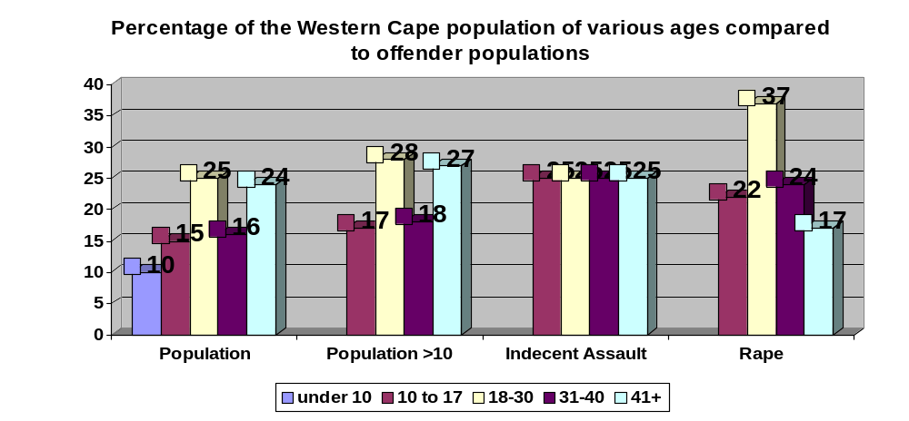

The first set of columns in the above graph shows the actual share of the population for each population group in the Western Cape in 2000. The second set of columns, titled ‘population >10’ works out the same percentages but excludes the under 10 population, as these form a negligible number of perpetrators (0.2%), to arrive at the population percentages of possible perpetrators. We are then able to compare the relative share of each age group of possible perpetrators with the actual share in the crimes of indecent assault and rape (columns three and four), committed against children in the Western Cape.

It is clear that children aged 10 to 17 contribute more to these kinds of crimes than might have been expected purely on the basis of their relative share of the population. However, that is largely to be expected, as here we are considering only crimes committed against other children, and it is more likely that if a child is to commit a sexual crime, that he commit it against someone of comparable age or younger than himself. It is also noteworthy that the contribution is higher for indecent assault than for rape.

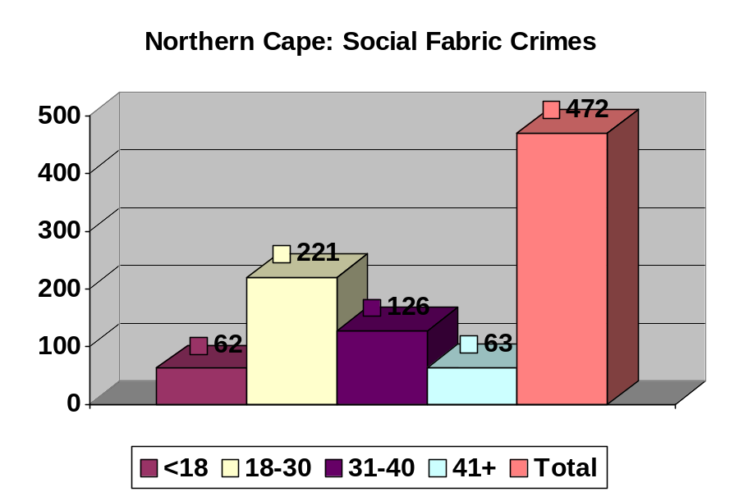Older people (41+) appear to contribute less to sexual crimes against children than their share of the population would predict. While persons 18-30 surprisingly contribute less to indecent assault than population share predicts, that is largely explained by their very high contribution to rape: it is possible that persons in this age group are more likely to rape a child than to stop at indecent assault. Persons 31-40 also contribute somewhat more to both indecent assault and rape than population would predict, and to a slightly greater extent than do children.

Comparison with social fabric crime in the Northern Cape
A comprehensive literature survey was not undertaken for the purposes of this report. However the findings of a study in the Northern Cape are relevant here. This study describes a docket analysis of 774 crimes selected from a total of 5869 social fabric crimes (murder, rape, assault GBH, indecent assault) committed between January and December 1997 in five major areas of the Northern Cape.

In 472 of these cases the age of the perpetrator was recorded, and the results appear in the graph above. Note that unlike the East Metro CPU analysis above, this study considers crimes in which victims were of all ages, and not just child victims. Consequently, it is of no surprise that in this study only 13% (62) of perpetrators were children, while 47% (221) were in the 18-30 age group.

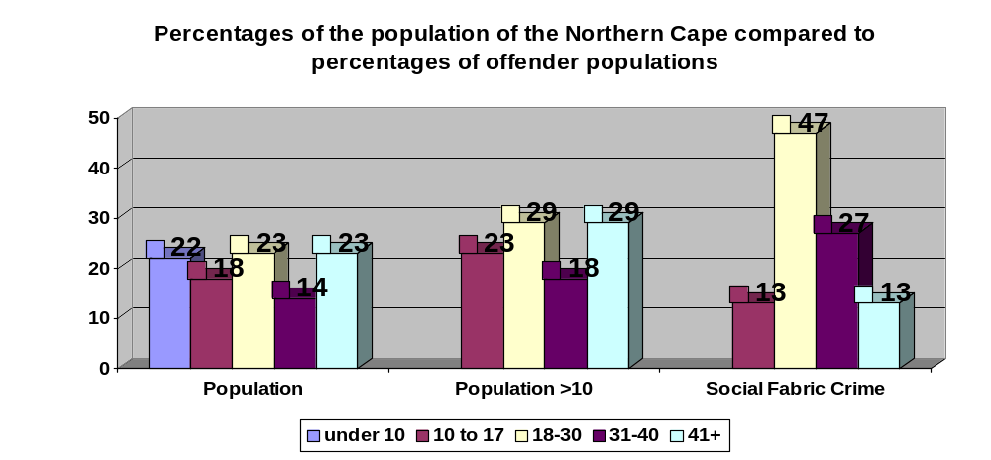

Carrying out the same exercise as for the East Metro data, (again persons younger than 10 accounted for less than 1% of perpetrators), comparing this with population data for the Northern Cape in 1997, we find that both children and persons over 40 committed fewer crimes than their share of the population might suggest, while persons 18-30 and 31-40 are committing far more social fabric crime than their share of the Northern Cape population might suggest.

Childline Research Statistics
Statistics from Childline are also useful in that they count incidents of sexual offences against children that may or may not have been reported to the police. In other words, they provide an indication of the extent to which such instances may be under-reported.

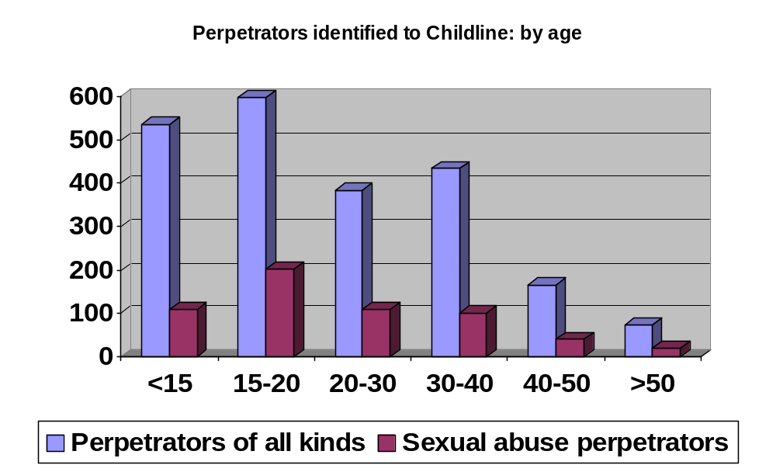Childline’s six provincial call centres, during the six-month period of July to December 2000, received 42 234 telephone calls, that is, approximately 230 calls each day, an average of just under 40 per day per call centre. Two thirds of calls, or 66%, were from children aged 11-15.

Of all calls, only one third (13 842) were calls with a specific need – the remainder were what Childline refers to as ‘test calls’, which Childline believes are from people or children testing Childline’s response, but unwilling to talk.

Childline finds these calls of concern as they indicate that many are unwilling to seek help. However, the statistics discussed here deal only with the ‘non-test’ calls.

The calls were analysed in terms of type, that is, whether they were in respect of physical abuse, emotional abuse, sexual abuse, and so on.

Of all calls, 91% related to an incident within the last year; 89% of sexual abuse calls related to an incident within the last year. Of all alleged perpetrators of all kinds of abuse, 85% were known to the child victim, 47% were parents, and 8% were stepparents.

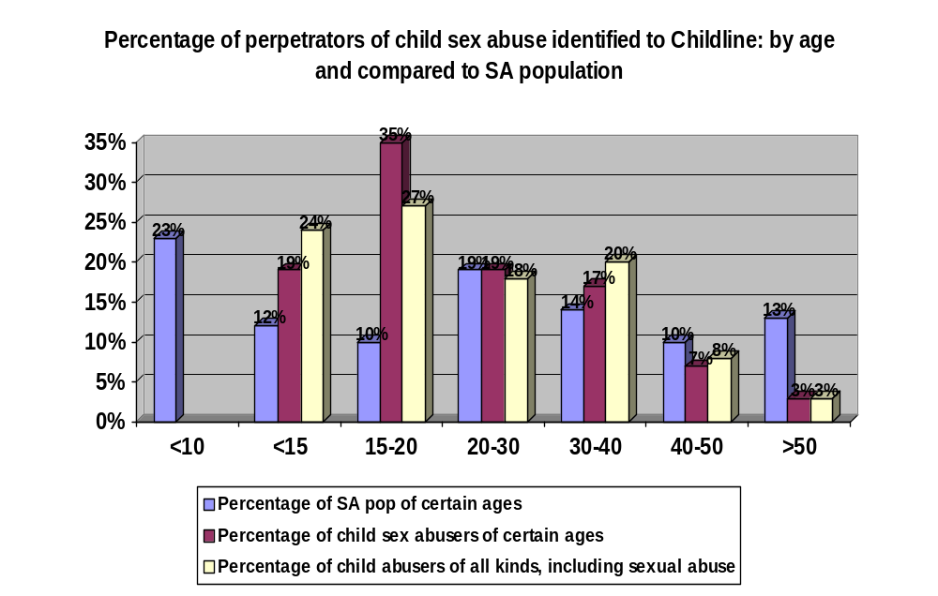The number of calls regarding sexual abuse, was 1734, or 13% of all calls. This was both intra-familial and extra-familial abuse. These figures are not evenly distributed throughout the country 20% were from the Eastern Cape, 22% from the Western Cape, 18% were from North West Province, 7% were from Gauteng, 7% were from Free State, and 7% were from KwaZulu-Natal.

The graph on the previous page shows the numbers of non-test calls of all kinds of abuse, and in particular, of sexual abuse, according to the age of the perpetrator identified by the caller. Not all callers identified the age of the perpetrator, so this graph only analyses the 2190 or 16% of all callers, and 584 or 34% of sexual abuse calls, in which the age of the perpetrator was identified. The graph on this page converts those figures to percentages, and compares those percentages to the percentage composition by age of the South African population as a whole.

This graph indicates that the under-15 population, the 15-20 population and to a lesser extent the 30-40 population account for more instance of child abuse and child sex abuse than is predicted by their share of the population.

In particular, the 15-20 age-group accounts for 35% of all instances of child sex abuse analysed by Childline. To some extent this is to be predicted as child sex offenders are more likely to offend against persons of the same age or younger than themselves. Nevertheless, it is worrying that 54% of all child sex abusers, and 51% of all abusers of children, are younger than 20 years.

The Western Cape accounted for 2218 or 16% or one-sixth of all calls. However, 483 or 22% of all Western Cape calls were in respect of sexual abuse, which is higher than the 13% average. Of all calls of sexual abuse, 483 or 27% were from the Western Cape.

Selected findings of other research
- A study by the Red Cross Children’s Hospital on sexually assaulted children seen between January 1991 and December 1999 at the hospital’s trauma unit traced the records of 200 such children (450-500 children were seen each year; however, all their records could not be traced). In only 22% of cases was the age of the assailant known. However, of the known cases, the average age of the perpetrator was 20.
- The 1998 Demographic and Health Survey found that 33% of rapes of persons under 15 were committed by schoolteachers.
- An SAPS docket analysis of crimes against children in Gauteng in 1996 and 1997 found that 46% of offenders were aged between 12 and 25. Further breakdown by age was not done, and commentators suggest that the 18-25 age group is likely to be responsible for the majority of such cases.
- A pilot study by the Psychological Society of South Africa of 180 reported cases of sex abuse where the victims were 11 or younger found the largest group of perpetrators to be in the 25-35 age group, followed by the 35-50 age group.

Conclusions

The fact that the number of un-sentenced children is consistently higher than that of sentenced children since 1999 is worrying. It suggests that a large number of children, whom the courts are loath to sentence with prison time, are spending time in prison. If the aim is to keep children out of prison as far as possible, it makes no sense that fewer are being sentenced, while more are spending time in prison un-sentenced. It also implies that children are spending time in prison in accordance with the vagaries of the criminal justice system, rather than after a court of law has duly considered a case and chosen prison time as the most appropriate punishment.

The fact that the ‘adult’ graph of sex offenders in custody over time is smooth compared to the child graph, also suggests erratic management of child offenders. There is a need to determine what is happening to child offenders who do not go to prison; it appears a significant proportion do not. This is not necessarily a problem if they are being appropriately addressed by diversion or other means, but it is not clear to what extent that is occurring.

The arrest figures do show that the number of arrests of children for sexual crimes committed against other children is increasing; however, the number of all arrests for such crimes is also increasing, and at a faster rate. This analysis therefore does not provide evidence of an ‘epidemic’ of child sex offenders. For all sexual crimes, the 18-30 age group remains the most problematic in respect of sexual crimes and this is largely confirmed by the findings of other research. However, it is recognised that significant under-reporting may occur. Children do nevertheless commit a significant portion of sexual crimes against other children; the Childline research indicates that the true extent of this problem may be somewhat hidden. Children’s involvement in sexual crimes against other children does appear to be lower for rape than for indecent assault.

What is of concern is the very small percentage of child sex offenders who are diverted from the criminal justice system. The large proportion for whom no outcome is recorded and the large number of withdrawn cases, are also worrying. Furthermore, comparing the prison numbers with arrest and prosecution numbers also suggests that many prosecutions are unsuccessful, which implies that most child sex offenders are simply going through the system without any impact that might affect their future behaviour. On the contrary, it is more likely that such an experience would lead to the belief that they could ‘get away’ with their behaviour despite being ‘caught’.

Nothing in this analysis suggests that the provisions of the Child Justice Bill are inappropriate for child sex offenders; on the contrary, the analysis suggests better management of such children is necessary. Furthermore, the relatively few reported cases at present suggest that such management would not involve an impossible task.

The figures provided by the SAPS gave breakdowns in the following categories: rape, attempted rape, “sodomy”, indecent assault, and “housebreaking with the intent to rape.” Adding the four categories together also did not lead to a figure matching the totals provided by the SAPS; the difference in these figures I have labelled as ‘unrecorded’ incidents.
National Coalition for Gay and Lesbian Equality v Minister of Justice and others, CCT11/98 1999(1) SA 6 (CC). Such cases should probably under the current legal framework be recorded as indecent assault, as South African case law considers intercourse per anum without consent to constitute indecent assault S v M 1979 2 SA 406 (RA); S v M 1984 4 SA 111 (T).
CIAC, SAPS. Crime per police area for the period January to December 1994 - 2000: Province: Western Cape; Area: Eastern Metropole
All provincial population estimates were calculated on the basis of Census 96 and the predictive table compiled by Calle Hedberg, HISP. The predictions take into account deaths due to HIV/AIDS.
Mistry, D, Snyman, R, & Van Zyl, M. Social Fabric Crime in the Northern Cape. Technikon South Africa. September 2001
All the statistics in this section are drawn from a Research Report compiled by Childline and kindly supplied by Lynne Cawood of Childline Gauteng.
Please note that the graph divides the SA population into 10-15 age-group and an under-10 age- group. Combined these age-groups amount to 34% of the population; however, to compare the number of child offenders to this large category which obviously includes babies and very young children, would not be sensible. Almost all child sex offenders, who are younger than 15 are in the 10-15 age group., as appears from the East Metro and Northern Cape research above.
Van As, AB, & Du Toit, N. Child Accident Prevention Foundation of South Africa and Red Cross Children’s Hospital Submission to Parliament on Sexual Abuse of Children, March 2002
Quoted in Jewkes, R, MRC Gender and Health Group Submission to Parliament on Sexual Abuse of Children, March 2002
Quoted in Dawes, A, UCT Children’s Institute Submission to Parliament on Sexual Abuse of Children, March 2002
Cooper, S & Watts, A, Submission to Parliament on Sexual Abuse of Children, March 2002

